**Design Patterns and Principles Outputs**

Exercise 1: Implementing Singleton Pattern

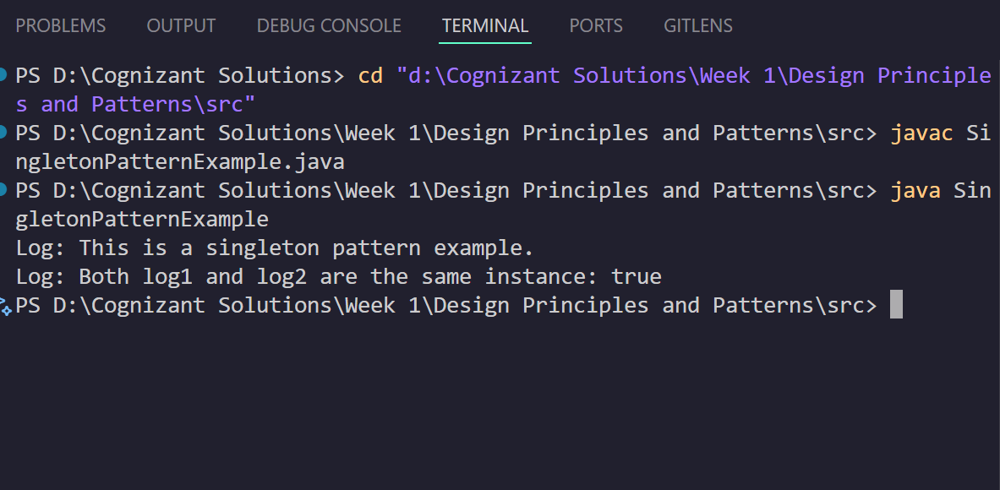

Exercise 2: Implementing FactoryMethod Pattern

